DCDP Year 2: Evaluation Report
December 2017

“Nurturing a sense of community identity and belonging”

Table of contents

1. Introduction
2. Overview
3. What we did
4. Data sources
5. Reflections
6. Place-based funding
7. Leveraging
8. Rank Associate
9. Upshot
10. Opportunities
11. Recommendations
12. Evaluation next steps
13. Funding next steps

Appendices:
Appendix A: Theory of Change Revisited: SWOT
Appendix B: Graphics
Appendix C: Draft proposal for showcase

1. Introduction
In our second report for Rank, we present our findings from the evaluation process carried out over the course of the second year of the Dundee Community Development Programme (DCDP).
We began by revisiting the Theory of Change process carried out in year one, and from this, captured views and perspectives on the continued relevance and value of the six outcomes identified by Rank. We also looked specifically at the ‘added value’ and ‘multiplying effect’ of Rank’s engaged philanthropy approach. In the individual evaluation interviews, we heard how these outcomes were experienced at the project level and gathered some more personal perspectives and feedback.
2. Overview
The funding of the 21 DCDP projects is, of course, fundamental to the success of the programme. Again and again, when we interviewed project leads, they talked about the difference the money makes. Often, it is the funding of a post that has made a difference, as at the V&A:
“Through the Rank funding of the post our reach is amplified, more people, greater range and diversity, e.g. numbers involved in garden project are not huge, but the engagement is massive; volunteers have gained in confidence and one has now got employment as a result”

Sometimes, the funding allows a project to exist, as at the Friary:
“We are enterprising with our resources, but we don't have much reach … Rank gives us the chance to be here at all”

At other times it’s a programme of work that has been funded, as with Dundee Rep:
“Health and wellbeing programme only possible because of Rank. We've been able to tailor it and develop it with nurture at its heart, e.g. Feelgood Friday members have become mutually caring and responsive to each other”

Rank’s unusually flexible and supportive approach is noted and greatly valued:

“Other funders create competitiveness, are insular and close you off; don't encourage collaboration. Opportunities for different levels of collaboration - one off workshops, tours etc, fitting in with what people need”

The intellectual and social capital is added through a wide-range of activities, including the Steering Group meetings. Many project leads commented on the huge value of these sessions, and the way they help to develop and strengthen connections:
“Rank facilitates the very essence of a network - links and connections”
There is a strong sense of solidarity and strength in numbers:
“DCDP supports resilience as there is a sense of ‘everyone is there, if need them’”

The view is that there are ‘warm’ contacts to reach out to through the network:
“Many conversations, but not all ‘live’, but we know we can ‘activate’ if we need to”

Many project leads talked about the value of not feeling alone:
“We’re all in this together”
That said, for small-scale projects with one paid member of staff, it can be difficult to connect externally as well as internally, especially where the worker is part-time:
“Challenge of making most of opportunities to connect and collaborate when working part-time, focused on getting job done and building/maintaining relationships in [the] organisation, and not necessarily have capacity to do more; feels strain of this. But finds it inspiring to hear about other projects”

Time to spend at Steering Group meetings and other networking events can be hard to find, but we heard repeatedly that this is seen as ‘time well spent’:

“The meetings and conversations have had a big impact on knowledge levels … [they] make you concentrate and [are] always beneficial”

This year, we have observed that the Steering Groups have become more focused and structured. The meetings and newsletter act as a resource and stimulus to the programme:

“the Steering Group brings us all together, increases awareness of who else is in the programme, what we all do and how people are working; newsletter gives a good update and sparks interest and ideas”
The evaluation is seen as another resource that helps to focus attention on impact and added value:
“… really value the SG meetings and evaluator input - opportunity to meet and network, to get a sense of context and find a place in the Rank 'family'. Empowering to understand how we all fit in together and the impact we have as a whole …”

DCDP enables projects to work across the city, across ward boundaries and across issues in a productive and powerful way.
This is welcomed and valued, although some project leads are (inevitably) concerned about issues of sustainability:
“Will things be sustainable over the long term; is the approach strong enough in terms of leveraging other resources and making major systemic change? Dundee has changed massively, but we are still looking at third and fourth generations of unemployment …”
The issue of sustainability has been on the minds of project leads this year, as the three-year funding draws to a close in 2018. Some concerns were raised about this in the August evaluation interviews. These were addressed by Rank’s Next Steps paper which was shared and discussed at the September Steering Group meeting.
3. What we did
The following table (Fig. 1) shows the activities we carried out during the second year. This activity largely followed the work plan we had developed at the outset. The only change is that the Showcase event has been moved to Autumn 2018.
4. Data sources
In writing this report, we have drawn from a range of data sources captured over the course of the year:
- Theory of Change Revisited
- Rank Associate interview
- Evaluation interviews
- Conference observation and feedback
- DCDP newsletters
- Annual returns to Rank
- RankNet
- Steering Group meetings - observation
Fig. 1: DCDP Evaluation Activities 2017 – Year 2
Timing |  | Activity | Participants |  |  | Outcome
Year 2: 2017
17 February | Case studies |  |  | SE | Full set edited & circulated (from 2016)
22 March | SG attendance |  |  | CME
9 May | ToCR session |  |  | Rank staff, Rank Associate and DCDP projects | To review and revise outcomes, and review progress
May | Interview with DD/GK |  |  | CME
21 June | SG attendance |  |  | CME/SE
21 June | Evaluation training |  |  | With Jacky Close | To build skills and confidence
24 July | Face to face interviews |  |  | DCDP projects/CME | To capture learning and progress against outcomes
30-31 August | Face to face interviews |  |  | DCDP projects/CME/SE | To capture learning and progress against outcomes
27 September | SG attendance |  |  | CME
5-6 October | Rank conference |  |  | CME/SE
14 December | SG attendance |  |  | CME/SE
December | Report |  |  | For Rank Trustees | To summarise findings and learning from Year 2

5 Reflections

5.1 Reflections on the six outcomes
In May 2017 we revisited the Theory of Change which had been created in two sessions in 2016, one with Rank senior staff and one with the projects. The purpose of this exercise was to see if the outcomes identified were proving to be the right ones, and to consider progress over the past year. We called this Theory of Change Revisited (ToCR). We used the opportunity to look at the strengths, weaknesses, opportunities and threats in the changing context (see Appendix A).

We particularly noted the key opportunities presented by the Fairness Commission (Faith in the Community and others) and the anticipated ‘uplift’ from the opening of the V&A; “it’s going to happen”.

It was clear that the six outcomes remain relevant and are now being owned by the projects. The over-riding sense is that Dundee is a caring city and that care underpins all the work of the projects at a time when the economic context is so challenging. Also, when the programme is entering its final year.

In the narrative that follows, we have drawn on findings from the ToCR and from the one-to-one interviews we undertook in August. We also include analysis of quantitative data we collected using a questionnaire as part of the interviews. We have used the six outcomes as our headings below.

5.1.1 Promoting cross sector collaboration
In the ToCR there was a strong sense that collaboration required real engagement through listening and encouraging participation (not just ‘doing to’). People felt co-production was important, as was empowerment, growing a culture of ownership and a focus on assets rather than deficits.

In our interviews we asked about connectivity as well as collaboration because we felt it was important to understand the relationship between the two.

Connections come in many forms as the following quotes illustrate:

“connections help with finding expertise”
“DCDP offers the connections that no other funder does”

“Rank facilitates the very essence of a network - links and connections”

“we are very connected; without the Rank network everything would have taken longer and might not have happened at all”
“Being part of DCDP helps. Makes us more aware of what we need to do, and gives us learning about other issues. Rank funding gives access to resources and potential for connectivity”

Inevitably not all projects are connected, but where connection happens it can play a very important role:
“our connection with the other projects varies, but where we are connected it is very strong”
“Holistically very connected. Directly - limited connections with some, but when we do it is very productive … Community structures are changing – committees, etc., essentially a good idea 'local democracy' but not always clear who to speak to, makes it harder to have direct links”

“Where [we] have worked with projects, the connection has been ‘intense’, ‘close’ and ‘mutually beneficial’

The sense that Rank is a different kind of funder comes across strongly:

“Rank gives us a common purpose, so I connect a lot with related projects, but also have the advantage of learning about other projects and perspectives. In the wider environment there is a lot of competition; not so within DCDP”

It was clear that the Steering Group meetings, the newsletter, Rank Associate team and RankNet were all, in different ways, supporting connection. More powerfully, they facilitate collaboration, working together and a “collegiate” approach.

The following quotes show the richness and range of collaboration that is going on:

“we have pulled together all the drop-in initiatives and given ourselves more of a collective voice in terms of offering a recovery programme”
“We are in the same building as three other Rank funded projects – this facilitates collaborative activity. The Steering Group meetings are really valuable as they make this easier … Rank has given a platform for potential collaboration outside Dundee”

“We’ve done a lot with Comic Space, PSYV and Bauer. A lot of our work is around communication and accessible formats/information … Collaboration is essential to our work, running Self Advocacy groups, etc. we couldn’t do without collaborating”

“Collegiate, in it together, more aware of other projects and know more about them. Closer and trusting relationships developed, which makes it easier to work together when the need or opportunity arises”.

The following story from Amina is a good illustration of how DCDP enables unexpected and unusual collaborations:

We heard that working with Dundee Rep ‘opened doors to opportunities’ for Amina. Over the summer, they also worked on a project with Comic School, where Urdu comics were used to engage the women. Drawing mangos became a way into culture, with women sharing stories about fruits arriving from ‘home’. The V&A collaboration engaged the women with Dundee’s waterfront regeneration through a site visit. Many of Amina’s women have lived in Dundee for 30 to 40 years; visiting the V&A has given them a sense of excitement and of being part of something new.
5.1.2 Developing resilience
From the ToCR, we understood that developing resilience was recognised by the projects as part of their responsibility. Projects see their role as building a nuanced understanding of poverty, anticipating needs, fostering solidarity and educating people to go beyond a focus on wards and local areas.
For many projects, resilience was about being able to adapt when things did not go to plan:
“... originally, we did think everyone would come to us and so we had to develop outreach, but we were able to do this, to adapt and approach it differently … access to people and connections through Rank projects, it has opened up connections and conversations”

“We are always adapting, making assessments of risk and changing what we do. Initially, setbacks with numbers – having to rearrange venues, costs, etc.”

It was clear from this and many other comments that Rank’s approach as a flexible funder supported the development of resilience. Many projects commented on how unusual this was from a funder and noted how valuable it was:
“Partnership with 'Youthlink' didn't pan out as expected and we had to adapt … support from Rank makes an enormous difference in that it provides a whole range of connections for collaboration. And the higher profile as part of DCDP has increased interest in us and we are able to respond”.
The graph below shows that well over half of the interviewees felt that being part of DCDP had actively supported the resilience of their organisation (23% ‘very much’ and 36% ‘much’):

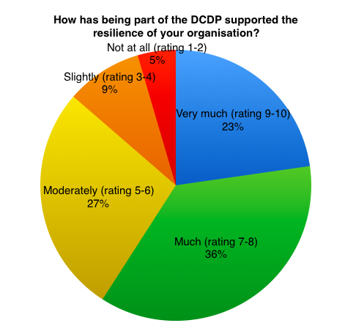
5.1.3 Purposeful, with clear intent and resourceful
From the ToCR, it was clear that projects saw their role as including:
- empower and give people voice
- facilitate
- give strong and consistent messages
- be stronger together
- create additional opportunities
- have a common purpose

It was noted that diverse partnerships are a strength, not a weakness. It was also noted that making best use of resources was a priority.

From the interviews, it was evident that the projects are very resourceful, in their recruitment and use of staff and volunteers, and generally in making the most of what they have. Being part of the programme enhances this natural resourcefulness:

“We do lots; respond; use what we have, adapt, and are open to what comes. Creativity is a core skill, of course, and we use this effectively. We provide the tools and help to build skills so that they can do their own stuff … programme is highly supportive of this approach”.

In interviews, we asked projects about how being part of DCDP supported their resourcefulness. An impressive 82% agreed that it did (32% ‘very much’ and 50% ‘much’). This makes resourcefulness one of the strongest features of the programme.

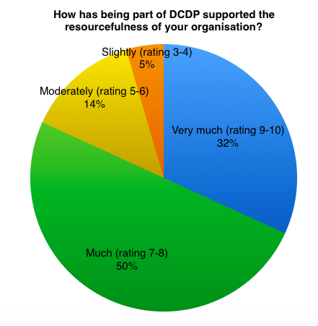
5.1.4 Sustainable self-directed community leadership
In the evaluation interviews, people made some important distinctions: between being a community leader (personally or organisationally) by virtue of being part of the community and the development of leadership by projects within communities. One project lead commented wryly:

“Leaders live in the community; I live on the Forth Estuary and drink Prosecco in my garden. I'm not a community leader”

Others felt that they had developed as leaders by being part of the programme. Many of them were aware that their function was one of ‘modelling’ leadership qualities and their application in a community development setting:

“Our role is to create community leaders through the projects we support … I am not 'of' Dundee therefore I bring leadership qualities to my role but wouldn't take this title … Rank has absolutely created community leadership”

“DCDP has improved leadership through contacts and connections [I] would not have thought of”.

In the interviews we asked project if their organisation’s community leadership had increased since the start of the programme; 91% said ‘yes’.

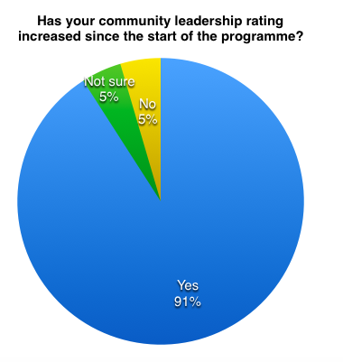

5.1.5 Dundee’s reputation for enterprising solutions for positive social change
In the ToCR, projects commented that ‘everything’ is potentially enterprising, and by giving people opportunities, communities will identify both the issues of concern and the ways to resolve them. The importance of Rank’s approach (‘the pebble in the pond’) is reinforced here, as the work of the projects is about encouraging people to get started, give a bit of help and get things happening:

“100% a bottom up approach – only way it would work, anything imposed meets resistance … People report positive life changes in response to the facilitation, creativity, enterprise, open and honest way we work with them. We are extending our reach, working with more people and including working families”

“Again, we weren’t getting it right in spite of effort, but with Rank money we could look at this afresh and release this enterprising energy into our work”

Later in the year, in the evaluation interviews, we uncovered a difference of opinion about enterprise. Some projects felt very strongly that being enterprising is not the most important thing; what matters most is being caring. For some there is a concern that the pressure on the voluntary sector to be enterprising makes the sector complicit with the market economy. For these people, the best outcome is to be able to no longer need to exist because the need has gone:

“We support a lot of deprived people, but we are not seeing much 'improvement’ - what does that look like? What would we see? We are enterprising with our resources, but we don't have much reach … Rank gives us the chance to be here at all”

“It's not about enterprise and shouldn't be - the goal is to close the doors. We are creative in response to what people present to us”

Other projects see their role as about supporting the development of enterprise in others:

“What we teach is creativity and we do it creatively. We encourage young people to be solution-focused and how to apply their skills to other scenarios and settings … One young person reported ‘I am using my imagination effectively, learning that it is healthy to make mistakes, this is the point of learning... I am not stupid’”.

In the interviews, we asked projects if their rating for contributing to Dundee’s reputation for enterprising solutions had increased since start of the programme; 82% said ‘yes’, which is line with the conversations about the role of enterprise.

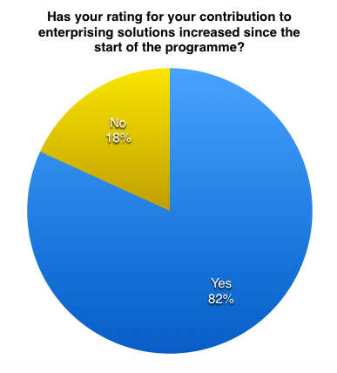

5.1.6 Dundee as the caring city
In the ToCR, projects identified care as underpinning everything they do:

“[the] main focus of Aspire is ‘care’: encouraging meaningful relationships between people”

For Foodbank Dundee, their project allows Dundee to show itself as caring:

“the generosity of people in Dundee is strongly evidenced, we give them a focus for that, collections at the football matches, etc.”

One project lead commented that the Steering Group meetings helped him to see the care in Dundee:

“DCDP allows me to see and share what’s going on. I see that people are very caring”.

In the interviews, we asked project if their rating for contributing to Dundee’s reputation as a caring city had increased since the start of the programme; 64% of interviewees said ‘yes’. We think that the reason this is not higher is because caring is seen as integral to what they do, a ‘given’ that the programme has further enabled:

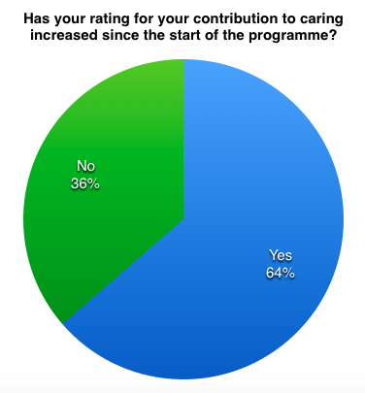

5.2 Reflections on other sources

5.2.1 Newsletters
The newsletter is compiled quarterly with each project contributing an update with a focus on achievements since the last Steering Group. Gillian Kelly pulls these together and then circulates them as an e-newsletter. The presentation of the newsletter has become distinctly more professional with each project’s logo and contact details being included. Overall, the newsletter contributions are informative, lively and positive in outlook.

We do notice that many of the updates are lengthy and can repeat information from earlier editions of the newsletter. We wonder if it might be helpful to provide a template, word count and guidance on focusing on what is new.

Reviewing the entries over the last year, it is clear that projects see progress and are able to describe their efforts and achievements. It is clear that in revisiting their plans on a quarterly basis, projects are reminded of the time it takes to get some activities ‘off the ground’ and of the enduring nature of the challenges faced by their beneficiaries.

Dundee Foodbank, for example, continues to identify new groups of people in need across the city. The project sees its role as combating the stigma associated with using foodbanks:

“[we are] concerned about the small number of people over 65 who use the Foodbank and [we] are attempting to contact this age group to inform them of our existence and make them aware they are able to apply for a nutritionally balanced food parcel. In 2017, only 33 over 65 years of age received a food parcel”

In another example, Aspire noticed that the children need new activities as they get older but experience a barrier in accessing other resources or mainstream provision across the city. Aspire is determined to address this, aiming to:

“… create a more holistic programme for teenagers that will hopefully nurture and support young people in different ways such as learning, education, health and wellbeing”.

5.2.2 Annual returns
The returns are completed by projects on an annual basis, in line with their funding cycle, so many are submitted in May and June. This means that the data provided by the annual returns is relatively ‘aged’ by the time of this evaluation report which is completed at the end of the calendar year.
The returns vary in detail and length, but most provide a useful and thorough overview of the project’s progress over the year. Specific questions about governance and about the use of Upshot provide information not captured elsewhere.
From the annual returns, it is clear that projects are focused on outcomes and impact, and are adapting their work to meet changing contexts. For City Church Dundee there is a “realisation that the numbers of people requiring support and the complexity of need is increasing”.
Many reports include succinct summaries of the positive difference made by the project’s work. For example, Amina reports:
“As a direct result of our intervention and service, women are more active, have more reason to leave the home, meet friends they normally might not make the time to see, and have improved routines and structure”
The annual returns include some stories of impact on individuals and groups. For example, Aspire report:
“We were able to take our ID group to the Dundee Comics Creative Space, where the young people took part in a comic workshop. The young people were really inspired by the creative space as well as the ideas and works of the artists who led the workshop [which] offered a great opportunity for them to develop their skills”
Only one project, Dundee Rep, use the report to focus specifically on sustainability and legacy:
“With the support of Rank, this work is now in a strong place with year three of funding to support the legacy of this work with our core programme. This legacy work and ensuring that the programme continues to develop with the highest artistic vision will be carried forward by a sole Head of Creative Learning for Dundee Rep with the support of the RCL team in project delivery”
The Time to Shine interns are seen as a valuable resource whose work makes a real difference. For example, Volunteer Dundee report really valuing the work that an intern can do:
“We are very fortunate to have a Time to Shine Intern Nikolaos Xypolitos in post to look at the market research and business planning for the Knowledge Exchange Network”.
As an aside, we were pleased to see this month that the business plan has been completed and will now be used by the project to raise funds for further work.
6. Place-based funding
It is clear to us that Rank’s place-based work in Dundee is adding great value to the city. The ‘engaged philanthropy’ approach, combining financial capital (grants), intellectual capital (including opportunities for shared learning, internships and access to training) and social capital (relational and networked) has the desired “multiplying or magnifying effect … where the outcome is greater than the sum of each part” (source: Rank paper, RFL RP & Place, April 2017).
From talking with David and Caroline, as well as our own experiences, we are noticing a growing interest in ‘place’. For example, in a recent speech in Edinburgh, Julia Unwin, former CEO of the Joseph Rowntree Foundation referred to the “fundamental shifts taking place throughout many aspects of society”:
“This includes the role of place and civic space … where people find their sense of belonging and identity”

She noted the crucial role of civil society as being where we can “show our best selves”. Civil society:

“support[s] a sense of local history and connection to place. This in turn can build resilience and the circumstances in which communities can exercise power and agency.” (Corra Foundation, Change Convention, Edinburgh, October 2017)

Rank’s involvement in a Cabinet office initiative, has resulted in the development of a place-based leadership project in Hull which launches in January 2018. It will be interesting to see how the debate around the importance of place develops in coming years.

7. Leveraging
Ten of the DCDP organisations have reported in their annual return that they have attracted additional funding (see Fig.2). This is twice as many as last year. In the second year of the programme, we can see that momentum is building and the attention of other funders is increasing, with significantly larger awards being made to an increased number of projects.
However, the reporting of this information is not always clear. The question in the annual return is ‘Has additional funding been secured on the back of the Rank Investment?’. Two projects replied ‘no’, but then reported funds raised, elsewhere in the return. This might suggest that some projects do not fully recognise the leveraging potential of the Rank funding.
As the projects move into their last year of funding and Rank makes decisions about phase 2 support, it might be useful for one of the Steering Group sessions to focus on fundraising and leveraging as a priority for all projects.
Fig.2 Additional funding for Rank DCDP projects
Project | Additional funding | Source/Purpose
Advocating Together | Approx. £81,000 | Dundee Health & Social Care Partnership
Amina | 28% increase in funding | DCC, People’s Health Trust, Garfield Weston Foundation, Alexander Moncur Trust, RBS skills and opportunities fund, NHS Tayside, Scottish Government (ALEC, PCF, VAWG)
Dundee Foodbank | £30,000 over 3 years | Robertson Trust
Dundee Foodtrain | £10,000 | Robertson Trust
Dundee Comic School | £3,000 | Converge Challenge Fund
Faith in the Community | £15,630  £79,922  £4,059 | Dundee Partnership Common Good Fund,  Scottish Government –  Fairer Scotland (Fairness Commission)  Community, Capacity and Resilience Fund (Wonderbox)
Link Up - Whitfield | £31,783  £2,085  £500  £300 | People’s Health Trust  Community Regeneration Fund  McInvest  Asda Foundation
Maxwell Town | £8,000 | Northwood Charitable Foundation
NE Under 12’s | Not specified | Community Regeneration Fund
V&A | £500,000  £50,000 | Garfield Weston  People’s Postcode Lottery

A positive example of Rank’s funding making a difference to an organisation’s case is shown here in this quote from the V&A’s report:

“We have also been told by capital funders, such as the Garfield Weston Foundation, who recently awarded £500,000 to our capital campaign for £50 million, that the community activity that we have already committed to, persuades them not only of the value of our project but the energy of our outreach programmes and the benefits they bring”
8. Rank Associate
In May, Claire met with David and Gillian to hear about the progress of the programme from their perspectives. A major focus for the team has been their development of the ‘Fun and Food Programme’. This initiative has had a major impact in the city, with over 6,438 meals delivered to children and their families over the October holiday this year, building on the ‘success’ of the summer programme.

Rank has facilitated this programme and it is an excellent example of leveraging funding and partnership working with Dundee City Council, Leisure and Culture Dundee, Dundee United Community Trust and the Outward-Bound Trust committing to the programme as well as a financial award of £25,000 from the Hillcrest group.

On a personal level, Gillian, who was new to the third sector, when she joined the team, has proved herself a “serious networker” and increased her areas of responsibility including recently being appointed Pilot Project Manager for the Dundee Bairns Tea Club.

From the evaluation interviews, it is clear that the Rank Associate team play a key role which is greatly valued by projects:

“David and Gillian are there, supportive. Gillian has presence and gives backing”

David is seen as ‘critical friend’:

“… his connections, but also his mentoring. I can pick up the phone to him; he offers guidance and constructive criticism as well as a sounding board”.

9. Upshot
The annual return asks specifically about the use of Upshot. The majority of projects responded very positively, reporting that Upshot has made a real difference:
“Upshot is an amazing tool. Every time staff have had the opportunity to participate in training we learn a little more of what it can do. Our main challenge is finding the time to upload our evidence, we are trying to use Upshot to gather all the information Advocating Together needs to hold”
Maxwelltown express concerns about losing Upshot:
“We are great fans of Upshot and feel it is a very valuable resource. We find it a really a useful tool for providing a wide range of internal and external reports for funders, stakeholders, partners and service users. We would hate to lose Upshot at the end of the funding period as to us as it has such a huge benefit to the project”
A few projects report that Upshot is useful, but has some limitations. For example, Faith in the Community feel that it does not measure the kind of work they do:
“It can measure the number of meetings and the amount of time spent at these meetings, but there is no facility to identify what benefits were gained by the faith communities through these meetings, i.e. an increased understanding of the recruitment process; an increased awareness of local agencies; an increase in awareness of the key issues facing people in Dundee”
Some report technical limitations. For example, Bauer report:
“We have found upshot extremely useful for collating all the student’s information (in terms of diversity and equalities). It has also been extremely useful to create timelines of the student’s journey throughout the course. The main issue that we have is it is extremely time consuming to upload ‘media’ being a multimedia course we have a lot of photos, audio and video and it takes a long time to upload this and tag it to the individual students and projects and dates etc. …”
Discoverin’ Families note the technical limitations, but reports that Upshot provides good customer service:
“Media uploads have proven difficult at times where you can only upload one image; when you try to add another, it deletes the picture uploaded before it. However, when issues have arisen, Upshot helpline staff have been very helpful and efficient”.
10. Opportunities
Project staff and volunteers have access to a range of opportunities to facilitate personal and professional development, using Rank grants.

In addition, projects are able to apply for a Time to Shine intern, which many projects in Dundee have done – more this year than last. Recently, Faith in the Community took on a ‘Rapper’ as part of the new Rank pilot initiative focused on youth leadership and social mobility.

In our evaluation interviews Jacky from Faith in the Community reported positively on the experience of managing a Time to Shine intern in 2016, and how the opportunities provided by Rank (e.g. launch conference, Four Seasons, film-making, etc.) had supported her management and leadership development.

However, generally, we were surprised to note how few other project leads mentioned take up of personal and professional development opportunities this year. We know from RankNet, that Dundee-based CPD is offered fairly regularly, so we are wondering if there may be an issue around travel beyond Scotland. In view of this, in 2018, it might help to promote these opportunities more consistently to Dundee projects, reminding people that Rank’s funding is available to cover travel as well as the training costs.

  - October conference
Both Claire and Siobhan attended the Rank conference in early October 2017. Staff and interns from the DCDP projects were present, along with the Dundee Rank Associate.

The conference was greatly enhanced by providing on line opportunities for engagement, such as live tweeting and voting at the Accelerator event. As one delegate commented, there was a “new slickness” to proceedings, which added to the enjoyment for many.

The conference as a whole continued to provide what one delegate referred to as “a safe place to think and reflect, be with like-minded people, but get new and sometimes challenging perspectives”.

The focus of the conference was ‘Thriving in Uncertainty’ and included a variety of interesting speakers and seminars ranging from the Tim Parry and Jonathan Ball Foundation for Peace to the Big Lottery Fund. The plenary session with Future Agenda provided an opportunity to think about changing context and future challenges, and was welcomed by many; one charity CEO commented that it was useful to have a chance to step back from everyday practice and think about the big picture.

The space to hear from, and engage with, high calibre speakers was, as one delegate commented, “really exciting, I wouldn’t get a chance ordinarily as I have little time to go on social media and do sometimes feel I am missing out”.

It was great to see Amina participate and win the Accelerator event. However, we noticed that there was no representation of the Dundee projects in the seminar sessions, which provide a good opportunity to showcase learning and impact and to build relationships within the sector. As DCDP draws to the end of phase 1, we would recommend that, at the next conference, Dundee projects present and speak, to increase visibility of the programme’s successes.

One other reflection on the conference, is that a number of interns were so inspired by the keynote talk given by Josh Littlejohn of Social Bite, that they signed up to take part in the Sleep in the Park in Edinburgh on 9 December.

10.2 Time to Shine interns
In 2017, a number of DCDP projects hosted Time to Shine interns: Advocating Together; Bauer and Cash for Kids; Dundee Comic School; Dundee Rep; Volunteer Centre. In addition, Gillian Kelly took on the crucial role of DCDP Co-ordinator supporting the Rank Associate, and as co-ordinator for the new Dundee Bairns initiative.
It is clear from meeting these interns at DCDP Steering Group meetings and other events including the Rank Conference, that the Dundee internships have been a great success. The interns have supported their projects in many ways, including marketing, developing social media presence, designing and delivering training, and business planning.
At our ToCR session in May, Norrie from Dundee Comic School created a visual record of discussions, and created a set of colourful and impactful graphics for the programme as a whole. Norrie and the Dundee Comic School also created witty cartoons of all the Time to Shine interns for use in the annual booklet.
The Dundee and Hull interns were grouped together as a cohort through the year and clearly connected strongly. Their showcase session at the Rank Conference was thoughtful and inspirational, as well as great fun! Gillian Kelly comments on this in her closing report for the year:
“The most memorable part of the year, has to be the annual Rank Foundation Conference in October, whereby myself and the other Dundee and Hull Interns, had the opportunity to put into practice our ‘showcase’ event which highlighted our different experiences, both on a personal and professional level. Whilst nerve wracking it was tremendous fun, and all us interns continue to keep in touch on a regular basis and reminisce”.
10.3 Training & development
As part of our approach to the evaluation as a whole, we aim to help build evaluation awareness and capacity within the projects. This year, we delivered a session to the projects on evaluation processes and approaches. This was also a direct response to feedback from some projects that they wanted to reflect on the process of evaluation at a project level.

Recognising that there is a great deal of experience of evaluation amongst the projects, we invited Jacky Close from Faith in the Community, to be part of the session and provide a ‘live’ input on her work with the Fairness Commission. The particular quality of the Commission’s evaluation process comes from the capturing of people’s real-life experience. Jacky’s passionate espousal of this approach and description of the practical processes involved really added to the impact of this session for the projects:

“I felt that Jacky’s description of The Fairness Commission approach was really important with its acknowledgment of the ‘real experts in the room’ – the Commissioners with ‘lived experience of poverty’ and that we have to find new ways to relate and make critical decisions with the people we serve”

Critically, a key message that Jacky shared about this process, and for all of us interested in meaningful evaluation was summed up by one of the Commissioners:

“I think it is good that they talked to us, but they need to follow through on what needs to be done”.

10.4 RankNet
We have noted and been impressed by the take up of RankNet in Dundee, including use by projects to ask questions and seek advice. Gillian is particularly good at promoting local opportunities, using RankNet.

10.5 Missed opportunities
We found the evaluation interviews both interesting and inspiring, however, we were slightly concerned, when interviewing the Chief Executive of Stewart Ivory to find that this project is failing to connect with any of the others. The CEO was aware of the potential for connection and collaboration, but did not seem committed to making the most of the opportunities. Given the degree of connectivity, collaboration and general positive perception of the multiplying effect, it was disappointing to meet a project lead who did not seem to appreciate the benefits.
11. Recommendations
As last year, we have framed our recommendations under two headings: ‘Do differently’ and ‘Do more’.

Many of these recommendations have already been mentioned in the body of the report, but we include them here, along with other suggestions as a ‘at a glance’ reference.

11.1 Do differently
We recommend that:
- Projects are provided with a template for newsletter updates, or at least a word count and guidance to focus on the ‘new’
- Projects are given guidance on the level of detail to be provided in the annual return, to ensure more consistent data
- Attention is paid to the issue of future and alternative funding sources, making the most of the leveraging opportunities offered by Rank’s funding. This might be the subject of a training session at one of the Steering Groups, using some of the expertise within the programme, e.g. Andrew at Inspiring Scotland
- Dundee projects are invited to run seminars at the Rank conference in 2018

At a programme level, we would recommend a meeting with David, Caroline, David and Gillian to talk about the evaluation. In 2018, a meeting on the day of the March Steering Group would allow us to discuss the showcase event planned for October in good time.

11.2 Do more
We recommend that:
- Opportunities for CPD in and beyond Scotland are promoted more consistently, and take up is actively encouraged.

At a programme level, we heard that the Rank Associate’s role as a mentor and critical friend was very welcome and made a real difference to some projects on governance issues. We recommend that this offer of support around governance is made more explicit, so that the project leads understand that they can use Rank as a sounding board and ally

We would welcome the opportunity to discuss these recommendations with the Rank team and Rank Associate.

12. Evaluation next steps
Next year, is the final year of phase 1 of DCDP, so our focus will be on capturing project learning from the whole programme experience. We will do this in the following ways:

- Attend Steering Groups, as before, providing inputs as required
- Organise evaluation interviews in June, to ensure that we talk with projects at or before the end of the three-year phase 1 funding. Where phase 2 funding has been approved, we will collect baseline data for Rank
- Support projects in showcasing their work (see Appendix C)

13. Funding next steps
At the Dundee Steering Group in September, David Dorward talked to DCDP projects about the opportunity to apply for additional funds. David Sanderson sent information, inviting each of the existing group to prepare a formal proposal, setting out your individual case for continued support, covering this key information, confirming Rank’s commitment to Dundee:

“We are delighted with the progress we have made in Dundee, individually and collectively. The evolution of a theory of change process and the independent evaluation have not only helped us to refine the methodology of this place based approach but to help create the conditions for meaningful collaboration and improved partnerships in the City. We aim to build on this for another three years”.

At the December Steering Group, David Sanderson thanked projects for applications and confirmed that next stage funding would be confirmed in the first quarter of 2018.

Appendix A: Theory of Change Revisited - SWOT Analysis
We reviewed the outset and input material and analysed it using a SWOT (Strengths, Weaknesses, Opportunities & Threats) approach.

Highlights under discussions about OUTSET include:
Strengths | Weaknesses
- DCDP: Pay living wage - lead by example  - Dundee Universities – best student experience in Scotland | - Economic context is challenging, e.g. Low pay traps people in poverty  - People not able to volunteer because they are tired and stretched
Opportunities | Threats
- Uplift from V&A: “It’s going to happen”  - Fairness Commission | - All services stretched - fewer providers, increasing need  - Professionals taking more on, facing barriers – need to embrace creative options, e.g. culture and social prescribing

In terms of discussions about INPUTS, highlights include:
Strengths | Weaknesses
- DCDP is “well-resourced” in terms of inputs and Rank’s flexible approach  - Client groups, volunteers & citizens shape the organisations and how they develop/design the offer | - “Over demanding” in terms of attendance at SG, evaluation & training sessions – there are capacity issues for individuals in some projects, i.e. part-timers with no admin support  - Charities Evening in November – a celebration event, but had hoped to get opportunities to meet other funders
Opportunities | Threats
- Associate & Time to Shine intern – signposting, connecting & overview  - Time to Shine interns as a resource | - Capacity and time to seek out and apply for other/future funding – for sustainability  - Recognition that Upshot is used variably across projects, even though part of Rank Funding agreement

Appendix B: ToCR Graphics - examples
Credit: Norrie Millar, Comic School


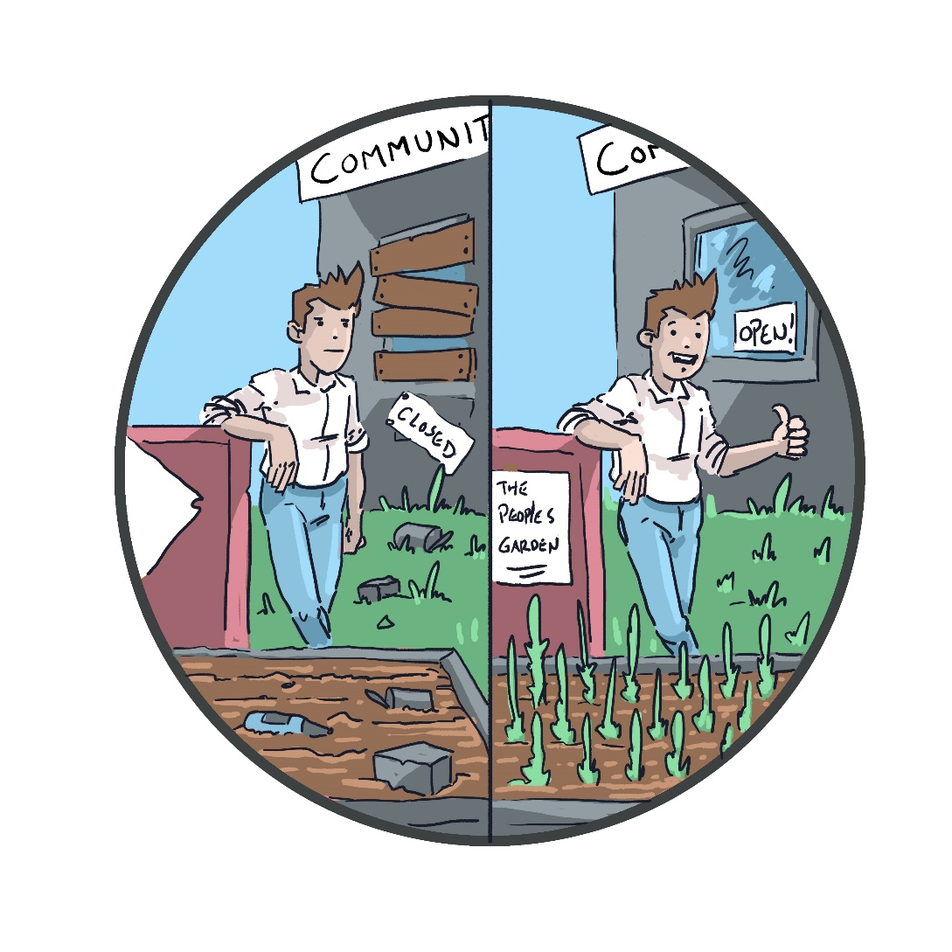
Appendix C: Draft proposal for DCDP showcase event at the V&A – September 2018
David and I had a brief discussion at the last SG about the proposed event for Rank projects.
We talked about an evening reception in the foyer of the V&A (Peter Nurrick is facilitating the booking of this) with guests including the big funders e.g. Big Lottery and philanthropists e.g. Chris Van Der Kuyl. A real celebration of the programme’s projects and of Dundee.
The following elements were identified –
- A 13-minute film produced by #Mission Ambition showing a key feature of each of the 21 projects
- A ‘flash mob’ performance by Dundee Rep’s “Beautiful People”
- A ‘take away’ comic about the projects produced by Comic School
- A food ‘installation’ by Maxwell Garden and Foodbank
- Norrie’s graphics for the evaluation on display
- Advocating Together greeters
- PSYV serving drinks, etc.

